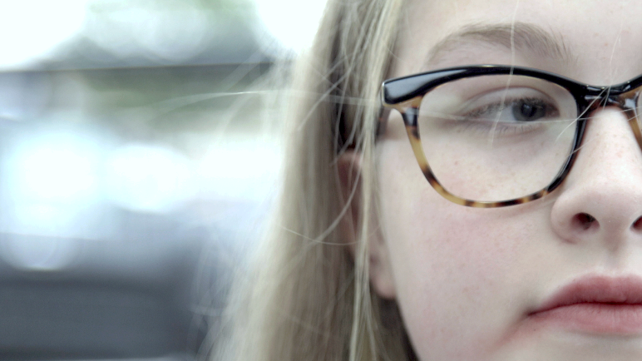

Georgia’s story – Supporting Activities

Film running time: 8 minutes
Advised session duration: 30 to 50 minutes
Film released: September 2019
Age rating: 12+
Contains references to drug taking, alcohol, drug dealing, violence and threats of violence.
Contains some scenes that viewers might find distressing.
Introduction:
Georgia appears on a train station platform early one morning at the beginning of September after a rough day the day before. At the station, she meets Alfie, a victim of CCE, who is still trapped in his situation.
It is based on real life events, although details have been changed to protect identities.
The film was co-written and made with young people in the Humber area. The locations and details shown are not intended to represent how and where these incidents took place.

Film link: https://youtu.be/apPbndS0ULg
or search ‘Georgia’s story not in our community’ on YouTube

Suggested follow-up materials:
- Visit www.notinourcommunity.org
- Follow Not in our community on Instagram, Facebook, Twitter, Snapchat or YouTube.

Closing message and accessing help:

Exploitation is never your fault.
If someone is in immediate danger call 999. If you have concerns about exploitation, you can call the local police on 101.

If you want to anonymously discuss concerns about grooming, sexual or criminal exploitation you can speak to Crimestoppers on 0800 555 111 or Childline on 0800 1111 or online.

Alternatively, you could speak with a trusted adult such as a parent, grandparent, carer, teacher, youth, health or social worker, and you can use www.notinourcommunity.org to work out the next steps to take together. There are also local organisations here to help you listed on the “Get help” section of the website.
Reflecting on Georgia’s story

- How did Georgia’s story make you feel?

Notes: it might be worth asking if they thought things like that happened where they live? You could ask if they feel Georgia deserves what is happening to her. It is worth reminding viewers that she is a child who is being controlled by adults and that what is happening is illegal. She is a victim.

- How could you tell Georgia was being sexually exploited? Where there any signs?

- What signs do you think Georgia could have spotted that Alfie was being groomed and exploited?

[Please see Grid 1 for examples – you could use these as a full list or cut them out individually. Groups might come up with additional suggestions.]

- How might it have felt for Georgia once the sexual exploitation started?

[Please see Grid 2 for examples – you could use these as a full list or cut
them out individually. Groups might come up with additional suggestions.]

- Do you think that this could happen around where you live?

- How might Georgia and Alfie be able to help each other?

[Please see grid 3 for examples – you could use these as a full list or cut them out individually. Groups might come up with additional suggestions.]

- What should Georgia and Alfie do next? Who can help them?
Notes: it won’t be easy for them to get out this, though nothing will change if they don’t try to get help.
Whilst they might not want to involve the police, they can call the local police on 101 or if in immediate danger, could call 999.
Alternatively, could speak anonymously to Crimestoppers on 0800 555 111.
They could speak with a trusted adult such as a parent, grandparent, carer, teacher, youth, health or social worker, and use www.notinourcommunity.org to understand what options they have.

Grid one
3. What signs do you think Georgia could have spotted that Alfie was being groomed and exploited?

Burner (second) phone | The packet that falls out of his pocket | Ditching mates
Being secretive | He’s not attending school | Acting defensive

Grid two
4. How might it have felt for Georgia once the sexual exploitation started?

She owed it to them | Mature | Scared or trapped
Humiliated or threatened | It was normal | There was no going back
Fun and happy | She wanted out | No-one would believe her
Confident and in control | She deserved it | Fooling herself it was OK

Grid three

- How might Georgia and Alfie be able to help each other?

Talk to each other to help them to understand they are the victims in their situations and it’s not their faults. | Speak to a responsible adult such as: a parent, carer, teacher, youth, health or social worker | Called 999 if they were in immediate danger
Alfie should tell Georgia to stop being stupid | Georgia should confront Dave | Gone uncover to collect evidence against the perpetrators

