Noah’s story
Noah enjoys gaming and is used to interacting with people online, often strangers he doesn’t know – it’s the norm for most people online gaming. Jacob befriended Noah and quickly gained his trust through gifts and listening to Noah talk about his problems. Through this false trust Noah was manipulated into meeting with Jacob and things quickly spiralled out of control, trapping Noah into a situation where he feels confused and trapped, and told he can’t get out of it.
Do not ignore the warning signs if you or a friend are at risk of sexual exploitation. See http://notinourcommunity.org/get-help/ to understand the options for help.
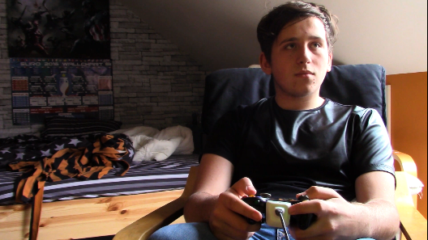
- I barely game with anyone from school anymore, not since I started gaming with Jacob! He’s great, he really gets how things are. He makes it easy to make sense of everything. I feel lucky to know him, he gives me credits and we just talk.

- I talk to him about things I don’t talk to anyone else about, how I really feel about things; school, family, what scares me, girls, and well you know. I’ve never met anyone like him before. Well, I say met, we haven’t actually met in person, but Jacob says we can soon. He says money isn’t a problem for him and that he can pay for a train ticket for me to go and see him

- He said I should tell my parents I’m going to stay at my mates and we’ll have a right laugh. I’m going tomorrow, night out and everything. It’s gonna be epic!

- I got what I wanted. I get to go out all the time now, not just with Jacob. He let me try lots of new things; he let me drive his car, drink, even take drugs. He showed me different ways of pleasure, you know, things I never thought I’d do. He introduced me to others guys online and they started sending me things too.

- I didn’t know there were so many amazing people out there. Well, some of them not so amazing it turns out. I’ve had to do some pretty rough stuff.

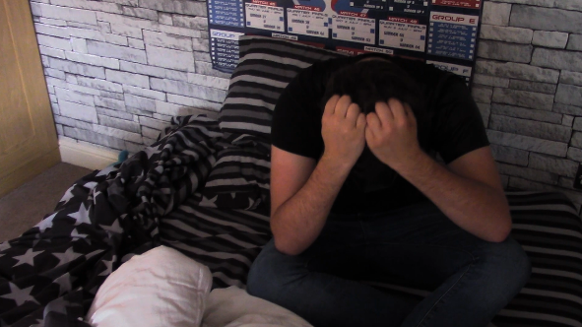
- Who I can trust. What is real and what is an act. Maybe I should just end it? That will show them all! I know Jacob says I can’t, but what if I did talk to someone else about this. Could someone make it stop? Do I even want it to stop? This is how things are.

